

**Installation & Users Guide**

Last Updated: December 14, 2014

logo.png

Table of Contents

1 Introduction 3

2 Open Source Licensing 3

2.1 License 3

2.2 Source Code 3

3 System Architecture 4

4 Installing Open Waters 5

4.1 Prerequisites 5

4.2 Installation Instructions 5

5 Using Open Waters 8

5.1 Organizations 8

5.2 Monitoring Locations 10

5.3 Projects 12

5.4 Activities (Chemical Sample, Biological Samples, and Field Data) 13

5.5 Data Import 14

5.5.1 Importing Monitoring Locations 14

5.5.2 Importing Samples 16

5.5.3 Importing Biological Metrics 18

5.6 Data Analysis 19

5.6.1 Maps 19

5.6.2 Graphs 20

6 Administering Open Waters 21

6.1 General Application Settings 21

6.2 Managing Users & Roles 22

6.3 Synchronizing Reference Data from EPA 24

# Introduction

Open Waters is a web-based water quality data management system that allows you to manage water quality monitoring locations, samples, results, and projects. It is intended for organizations that wish to synchronize their water quality data with EPA’s WQX system. Some high-level features of the application are:

* **Water Quality Data Management:** Manage your water quality samples & results, monitoring locations, projects, and organizations
* **Automatic WQX Submission:** Data is automatically submitted to EPA’s WQX program (<http://www.epa.gov/storet/wqx/>) as it is entered (if data is flagged for submission to EPA)
* **Reference Data Synchronization:** Reference data (e.g. Pollutant names, Taxonomic names, analytical methods, etc) are fully synchronized with EPA’s reference data, ensuring that submissions will not fail due to mismatches in reference values.
* **Bulk Data Import:** Data can be bulk imported from a spreadsheet, saving time on data entry.
* **Application Customization:** Application can be customized to show or hide various data elements, allowing application administrator to streamline the application screens to only include the data elements of interest to the Agency staff.
* **Security:** Role-based application security and additional layered security measured to ensure security of data
* **Multi-Agency Support:** Allows multiple agencies (called Organizations) to share the application; all data and data security is segmented by Agency.
* **Open Source:** Application is free to use, free to share, and free to modify

# Open Source Licensing

## License

Open Waters is free software: you can redistribute the source code and compiled software and make modifications under the terms of the GNU General Public License v3 as published by the Free Software Foundation, either version 3 or (at your option) any later version.

This program is distributed in the hope that it will be useful, but without any warranty; without even the implied warranty of merchantability or fitness for a particular purpose. See the GNU General Public License for more details. See here for a complete text of the license terms: <http://www.gnu.org/licenses/gpl.txt>

## Source Code

Source Code for Open Waters is available at: <http://code.google.com/p/open-waters/>.

* **Obtaining the Installation Package:** To download a copy of the installation package, click on the Download tab (<http://open-environment.org/openwaters.html>).
* **Obtaining the Source Code:** To download a copy of the source code, click on the Source tab (<http://code.google.com/p/open-waters/source/checkout>) and use a tool such as Subversion to synchronize with the project repository.
* **Contributing Source Code:** Developers are encouraged to join the Open Waters development team. If you are a developer who wishes to contribute to the Open Waters development, contact a team member listed at (<http://code.google.com/p/open-waters/>). A team member will add you to the project team.

# System Architecture

The following diagram depicts the Open Waters application architecture:

**Open Waters**

**EPA**

**Open Waters Web Application**

**WQX Reference Data**

**WQX Warehouse**

**Windows Service**

**CDX Node**

**Open Waters Database**

**WQX Submission**

***Figure 4.1: Open Waters System Architecture***

The overall solution is divided into the following major components:

**Open Waters Database:** A Water Quality Database that closely mimics the EPA-WQX data structure.

**Water Quality Data Management System:** A variety of data management screens are provided to allow staff to insert/update/delete water quality data (i.e. projects, monitoring locations, samples, and results).

**WQX Reference Data Synchronization:** The Open Water web application interfaces directly with EPA’s WQX Domain services (<http://www.epa.gov/storet/wqx/wqx_getdomainvalueswebservice.html>) to pull the latest set of valid WQX reference data. These reference values are then used by the data management system to populate relevant drop-downs during the data entry process.

**Open Waters Windows Service:** A Windows Service is also installed on the Web Server. This Windows Service controls the scheduling of the submission of WQX data to EPA.

# Installing Open Waters

## Prerequisites

Before installing Open Waters, your hosting environment must meet the following requirements:

* **Web Server:** 
  + Windows Server 2003 or later (IIS 6 or later)
  + .NET Framework 4.0
  + Microsoft Web Service Enhancements (WSE) 2.0
  + Microsoft Web Service Enhancements (WSE) 3.0
  + Web server can communicate with Internet (no firewall prohibiting access to EPA’s WQX server)
  + Web server can communicate with Database Server
* **Database Server:** 
  + SQL Server 2008 or later (Express edition is OK)

## Installation Instructions

To install Open Waters, follow these steps:

1. Make sure all prerequisites from the previous section have been installed
2. **Database Installation:**
   1. Login to SQL Server Management Studio and run the script called **Create_DB.sql**. This will create a new database called OpenEnvironment, and create several database tables and stored procedures.
   2. *(Optional)* It is then recommended that you change the password for the **oe_login** SQL Server account user from the default in the provided script.
   3. *(Optional)* If you have been given an additional script to populate the database with your agency’s water quality data, then run this (note: this is not provided by default).
3. **Application Installation:** 
   1. Unzip the provided OpenWaters.zip to a directory on the Web Server where you would like to host the application.
   2. Open up the Web.config file - find the following block:

<connectionStrings>

<add name="OpenEnvironmentEntities" connectionString="*** />

</connectionStrings>

Change the values of the data source, username, and password to match the database installed in Step 2 above.

* 1. Change the dir value of the following block:  
     <add key="ChartImageHandler" value="storage=file;timeout=20;dir=c:\TempImageFiles\;" /> to point to a valid file path on your web server.
  2. Open up IIS. Create a new Virtual Directory called “OpenWaters”, pointing to the location where you unzipped the application files.
  3. Restart IIS
  4. Browse to the following directory to confirm that the application is working: <http://localhost/OpenWaters>

1. **Install Windows Service:** Open Waters includes a Windows Service that will periodically submit data to EPA as a background process.
   1. Unzip the OpenWatersSvc.zip to a directory on the server
   2. Open up the OpenWatersSvc.exe.config file - find the following block:

<connectionStrings>

<add name="OpenEnvironmentEntities" connectionString="*** />

</connectionStrings>

Change the values of the data source, username, and password to match the database installed in Step 2 above.

* 1. Open the **Install.bat** file and change the directory to match the location where you have copied the service files (Step 4a above).
  2. Run the **Install.bat** file, by clicking Start🡪Run🡪type in cmd🡪 then type in <path>\OpenWatersSvc.bat **(you must run as Administrator)**
  3. Confirm the service is running by going to Control Panel🡪Administrative Tools🡪Services. A service entitled “Open Waters Service” should be listed.

1. **Initial Application Configuration:** After the application has been installed, there are some initial configuration steps that will improve system behavior:
   1. General Application Settings: Set the following general application settings (follow the instruction in Section 5.1):
      1. CDX Submission URL: The web service web page of EPA’s CDX Node to which WQX submissions will be made (this will be set but may need to be changed depending on whether you will be submitting to EPA’s test or production environment)
      2. CDX Ref Data URL: The web service web page of EPA’s domain service from which Open Waters will retrieve reference data
      3. CDX Submitter: This is the default NAAS account that will be used to submit data to EPA. [Important: If you plan on hosting data for multiple organizations, who will manage their data separately, then you will want to configure Organization-specific CDX Submitter usernames/passwords (at the Organization screen) as opposed to setting it here.]
      4. CDX Submitter Password: The default NAAS password that will be used to submit data to EPA [Important: See note in line above]
      5. EMAIL_FROM: the name of the sender used when Open Waters distributes emails
      6. EMAIL_SERVER: the address of your SMTP server that Open Waters will use to distribute emails
      7. EMAIL_PORT: the port used by the SMTP server you are using to distribute emails
   2. Synchronize Reference Data: by default, Open Waters does not have any reference data populated. **To populate reference data, an initial synchronization must be performed.** Follow instructions in Section 6.3.
   3. Add users: you may wish to add more application users or administrators. Follow instructions in Section 6.2.
2. **Start the Windows Service:** The Windows service is used to push data from Open Waters to EPA’s WQX.
   1. Go to Control Panel 🡪 Admin Tools 🡪 Services.
   2. Click the Start button to start the Open Waters service
3. **Enter in an Organization and grant at least one Open Waters user rights to edit data for that Organization** (see section 5.1 for more details).

# Using Open Waters

## Organizations

**Site Navigation:** Water Quality 🡪 Organizations

An organization describes the agency managing the water quality data. Having at least 1 organization record in the database is essential before any water quality data can be transferred to EPA-WQX.

**Your Organization ID will be assigned to you from EPA. Please contact EPA if you do not have a WQX Organization ID or are unsure of its value. The ID used in Open Waters must match the ID assigned by EPA.**

The Organization webpage lists all organizations in a datagrid, as shown here:

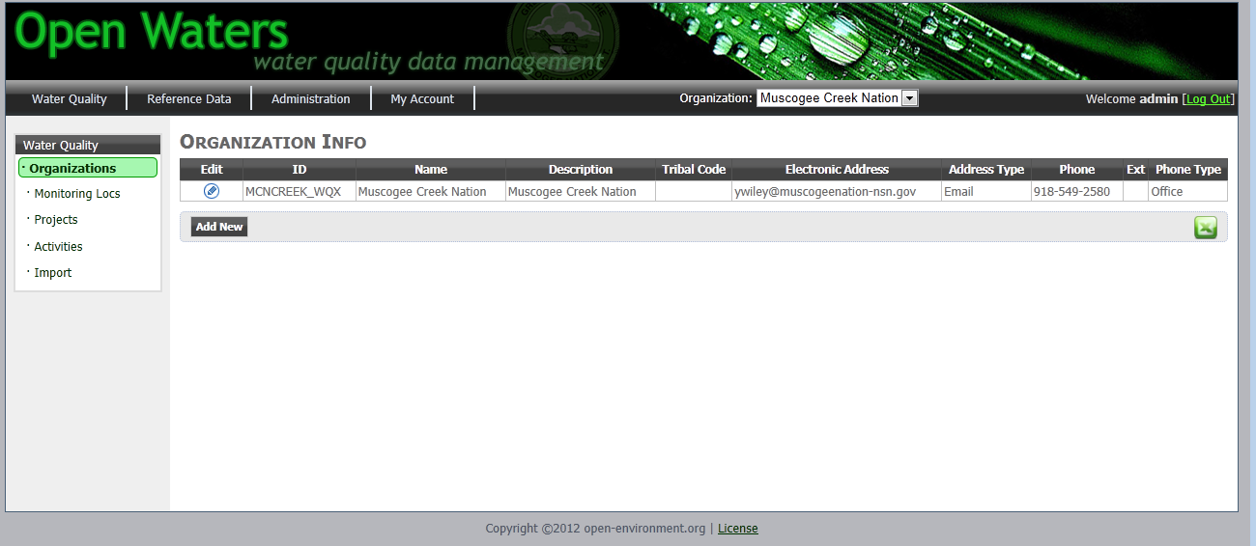

***Figure 5‑1 Organization Listing Page***

Open Waters support the management of multiple Organizations.

**Edit an Existing Organization:** To edit an organization, click the pencil icon in the first column for the monitoring location you wish to edit. This will display the Edit Organization screen, as shown here:

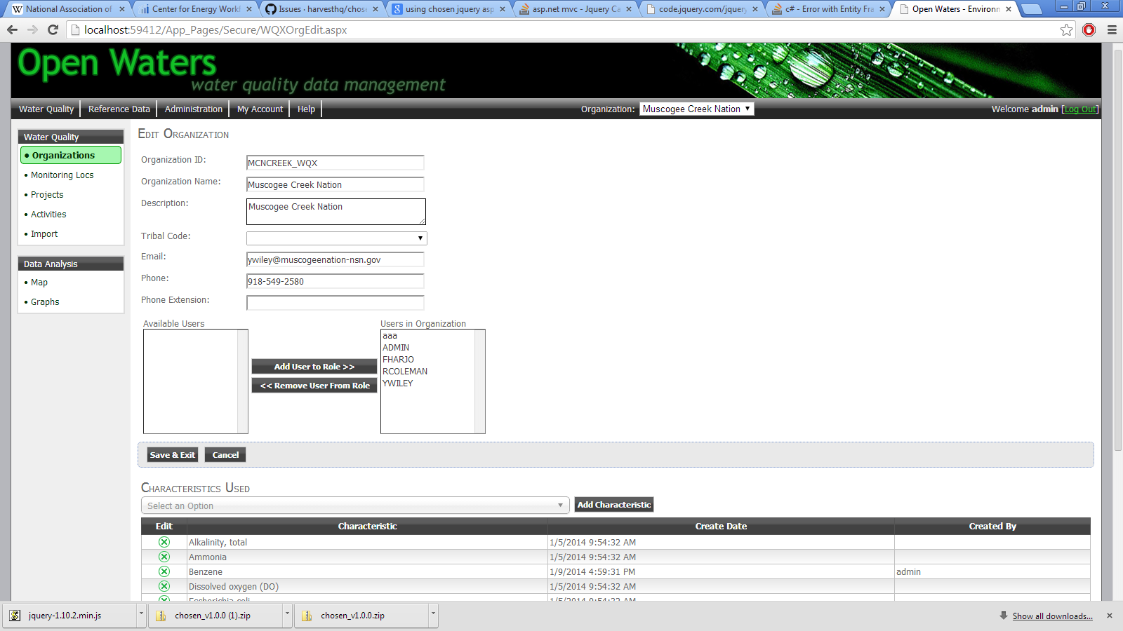

***Figure 5‑2 Organization Edit Page***

On the Organization Edit page, you can modify the following information:

* General organization details
* Which Open Waters users can access and edit data for this organization
* CDX Submitter: specify the NAAS account to be used to submit this organization’s data to EPA/CDX.
* Specify which characteristics the organization will sample for: By Default, EPA provides 1000s of chemical characteristics. To speed up data entry of samples, you can define a subset of these 1000+ chemicals that may actually be sampled by your organization.

Make your changes and click the Save button.

*Note: your changes will not be transferred to EPA until another piece of data has been updated (i.e. Monitoring Location, Project, or Activity).*

**Add an Organization:** Only users that have ADMINS role can add a new Organization. Click the button and a new Organization will be created.

**Export to Excel:** Click the Excel icon ( xls.png ) to export the listing of Organizations to Excel.

## Monitoring Locations

**Site Navigation:** Water Quality 🡪 Monitoring Locations

Monitoring Locations identify the specific places at which water quality sampling or other activities (i.e. habitat assessments) are performed.

The Monitoring Locations page lists all monitoring locations in a datagrid, as shown here:

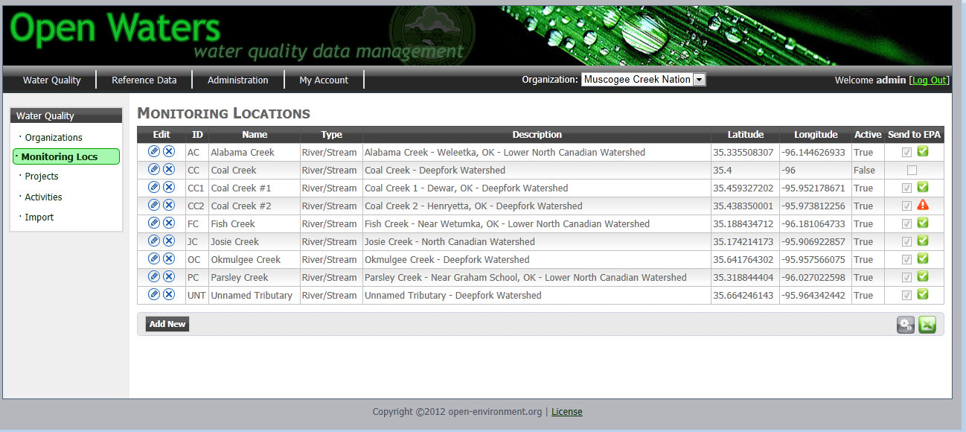

***Figure 5‑3 Monitoring Location Listing Page***

**Deleting a Monitoring Location:** To delete a monitoring location, click the “X” icon in the first column of the datagrid for the monitoring you wish to delete. Note: this will not completely remove the record, but will instead mark as inactive and trigger a submission of a delete file to EPA.

**Adding a New Monitoring Location:** To add a new monitoring location, click the **Add New** button at the bottom of the page.

**Edit an Existing Monitoring Location:** To edit a monitoring location, click the pencil icon in the first column for the monitoring location you wish to edit. This will load the Edit Monitoring Location page, as shown here:

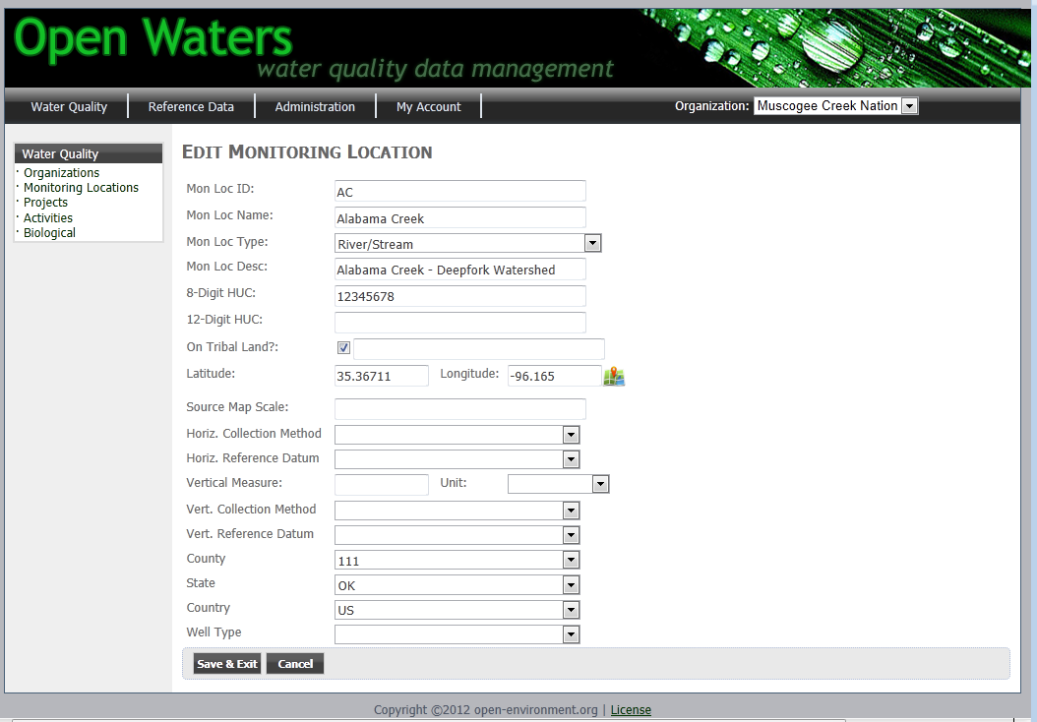

***Figure 5.4: Monitoring Location Edit Record Page***

**Submitting Monitoring Locations to EPA WQX:** You can select which monitoring locations are submitted to EPA by clicking the “Send to EPA” checkbox. When a monitoring location is modified and is marked to submit to EPA, it will be flagged with in the database. The Open Waters background service will run (usually within a minute after data has been entered or modified); it will query all records from the database that are flagged as pending transfer to EPA and attempt to submit them to EPA-WQX. The record will be flagged as follows:

: Record failed in its most recent submission attempt to EPA.



: Record successfully submitted to EPA is most recent submission attempt.



progress.gif: Changes have been made to the record and the record has either (A) not yet been submitted to EPA, or (2) submission has been made, but feedback from EPA on submission success/failure has not yet been received.

**View WQX Submission History:** To view a history of submissions made to EPA for the particular record, click the status icon in the last column, which will display the following screen:

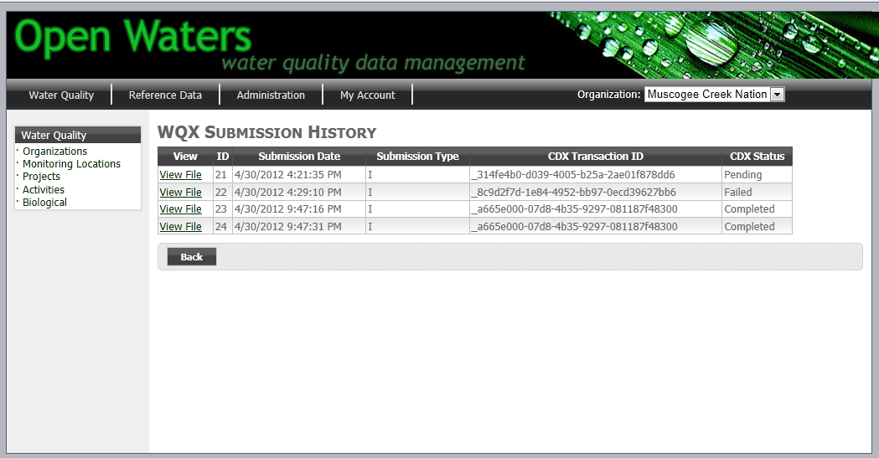

***Figure 5.5: WQX Submission History Page***

**Export to Excel:** Click the Excel icon ( xls.png ) to export the listing of Monitoring Locations to Excel.

**Bulk Import Monitoring Locations:** If you have many Monitoring Locations you wish to import from a spreadsheet, you can do this at the Import screen (see Section 5.5 for more details).

## Projects

**Site Navigation:** Water Quality 🡪 Projects

Projects are a way of logically grouping Sampling Activities.

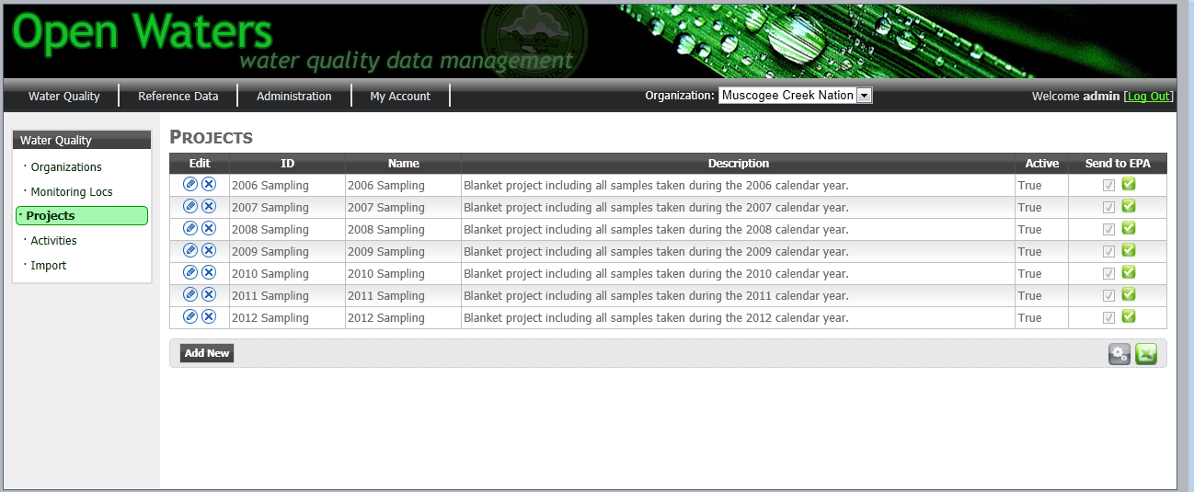

***Figure 5.6: Project Data Management Page***

Management of Projects (i.e. Insert/Update/Delete as well as WQX Submission history tracking) are similar to that of Monitoring Locations covered in the previous section.

**Export to Excel:** Click the Excel icon ( xls.png ) to export the listing of Projects to Excel.

## Activities (Chemical Sample, Biological Samples, and Field Data)

**Site Navigation:** Water Quality 🡪 Activities

The Activities page allows you to track all sampling activities, including samples and results. This includes both chemical samples, biological samples, field data and/or QAQC data.

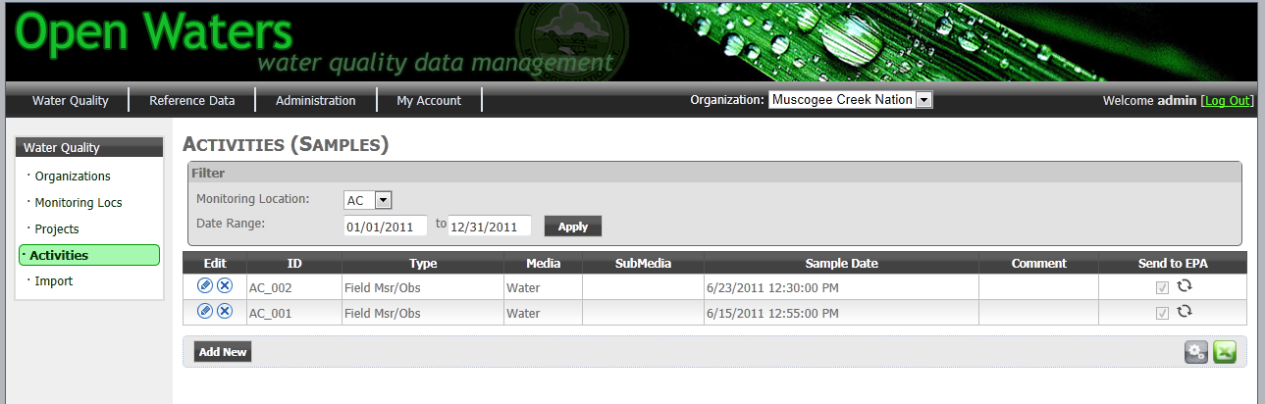

***Figure 5.7: Activities Data Management Page***

**Data Filters:** You can filter the display of Activities by Monitoring Location and sample date range.

**Management of Activities** (i.e. Insert/Update/Delete as well as WQX Submission history tracking) are similar to that of Monitoring Locations covered in the previous section.

**Results Editing:** When on the Activity edit page, you can also add or edit the sampling results for each characteristic sampled, as shown here:

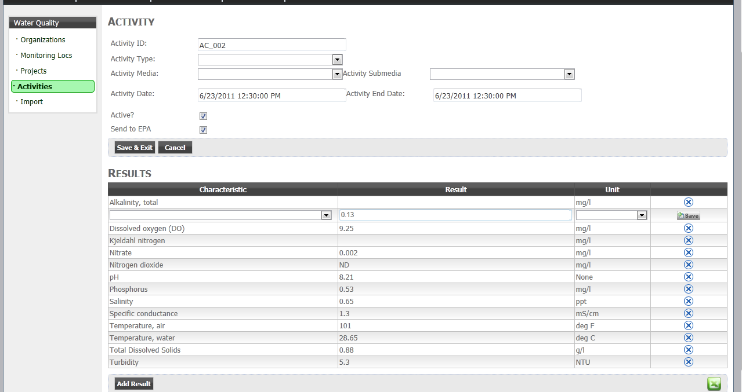

***Figure 5.8: Activity Details/Result Data Management Page***

By default, the drop-down of characteristics will be limited to only those characteristics associated with your organization. To modify this list, please go to the Organization Edit page (see section 5.1).

**Data Validation of Results:** OpenWaters will perform the following data validation on results as they are entered:

* **Valid Results Values:** The following values are allowed for results:
  + Any numeric value
  + ND: Non-Detect
  + NR: Not reported
  + PAQL: Present above quantitation limit
  + PBQL: Present below quantitation limit
  + DNQ: Did not quantify
* **Result Range Checking:** When results are entered, Open Waters may check that the result falls within a valid range. This check will only be performed if a record exists in the T_WQX_REF_CHAR_LIMIT table for the Characteristic/Unit combination that is being entered.

## Data Import

**Site Navigation:** Water Quality 🡪 Import

### Importing Monitoring Locations

You can bulk import monitoring locations by filling out a spreadsheet and copy-pasting the data from the spreadsheet into the large textbox on the Import page.

Click the “Download a Blank Import Template” link to download a blank Excel file.

When copy/pasting the data into the blank textbox, **make sure you also paste in the column headers.** Open Waters uses the names of the column headers to determine what data is being imported. This allows you the flexibility to reorder, add, or remove columns, while still being able to import the data in quickly.

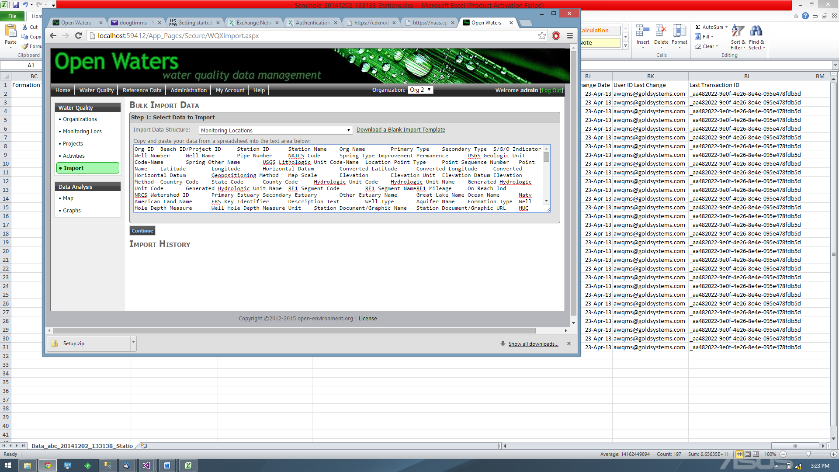

Column header included in paste

***Figure 5.9: Monitoring Location Import Bulk Data***

Open Waters reads in the following column headers and performs the following data checks:

|  |  |
| --- | --- |
| Column Header Must Be | Import Validation Checks |
| Station ID | * Checks whether unique Station ID already exists in database * Length check (25 characters) |
| Station Name | * Length check (255 characters) |
| Description Text | * Length check (1999 characters) |
| Primary Type | * Length check (45 characters) * Checks against valid EPA reference list |
| HUC Eight Digit Code | * Length check (8 characters) |
| HUC Twelve Digit Code | * Length check (12 characters) |
| Tribal Land Indicator | * Length check (1 characters) |
| Tribal Land Name | * Length check (200 characters) |
| Latitude | * Check if decimal |
| Longitude | * Check if decimal |
| Map Scale | * Check if integer |
| Geopositioning Method | * Length check (150 characters) * Checks against valid EPA reference list |
| Horizontal Datum | * Length check (6 characters) * Checks against valid EPA reference list |
| Elevation | * Length check (12 characters) |
| Elevation Unit | * Length check (12 characters) * Checks against valid EPA reference list |
| Elevation Method | * Length check (50 characters) * Checks against valid EPA reference list |
| Elevation Datum | * Length check (10 characters) * Checks against valid EPA reference list |
| Country Code (will only accept 2 digit Country Codes) | * Length check (2 characters) * Checks against valid EPA reference list |
| State Code (will only accept 2 digit State Codes) | * Length check (2 characters) * Checks against valid EPA reference list |
| County Code (will only accept 3 digit FIPS County Codes) | * Length check (3 characters) * Checks against valid EPA reference list |
| Well Type | * Length check (255 characters) |
| Aquifer Name | * Length check (120 characters) |
| Formation Type | * Length check (50 characters) |
| Well Hole Depth Measure | * Length check (12 characters) |
| Well Hole Depth Measure Unit | * Length check (12 characters) |

After you have pasted data, click the **Continue** button. Open Waters will validate each record according to the logic in the previous table to determine if it can be imported. Validated data are then displayed, as shown here:

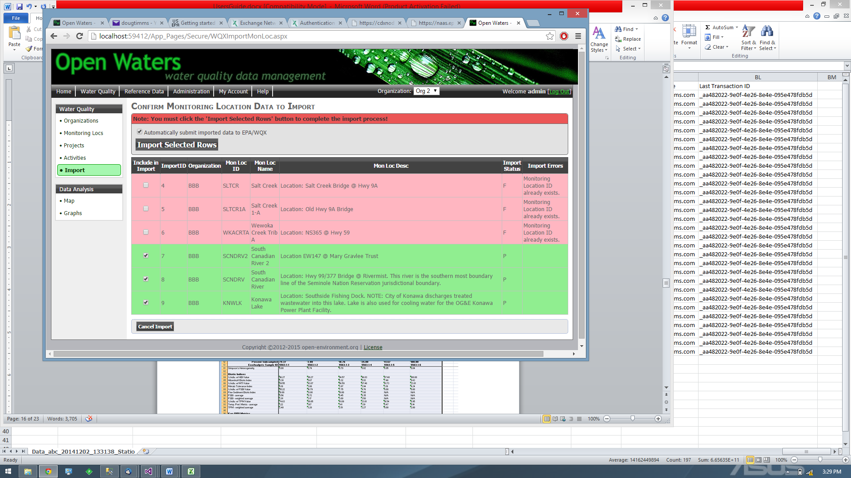

Records that have passed validation are shown in green; records that have failed validation are shown in pink.

You can then click the **Import Selected Rows** button to complete the import process. Or you can click the **Cancel Import** button to cancel the import process and start over.

### Importing Samples

Currently cross-tab sampling templates can be imported. These are sampling templates where each row in your spreadsheet contains one sample, with sampling results appearing in different columns. An example is shown here:

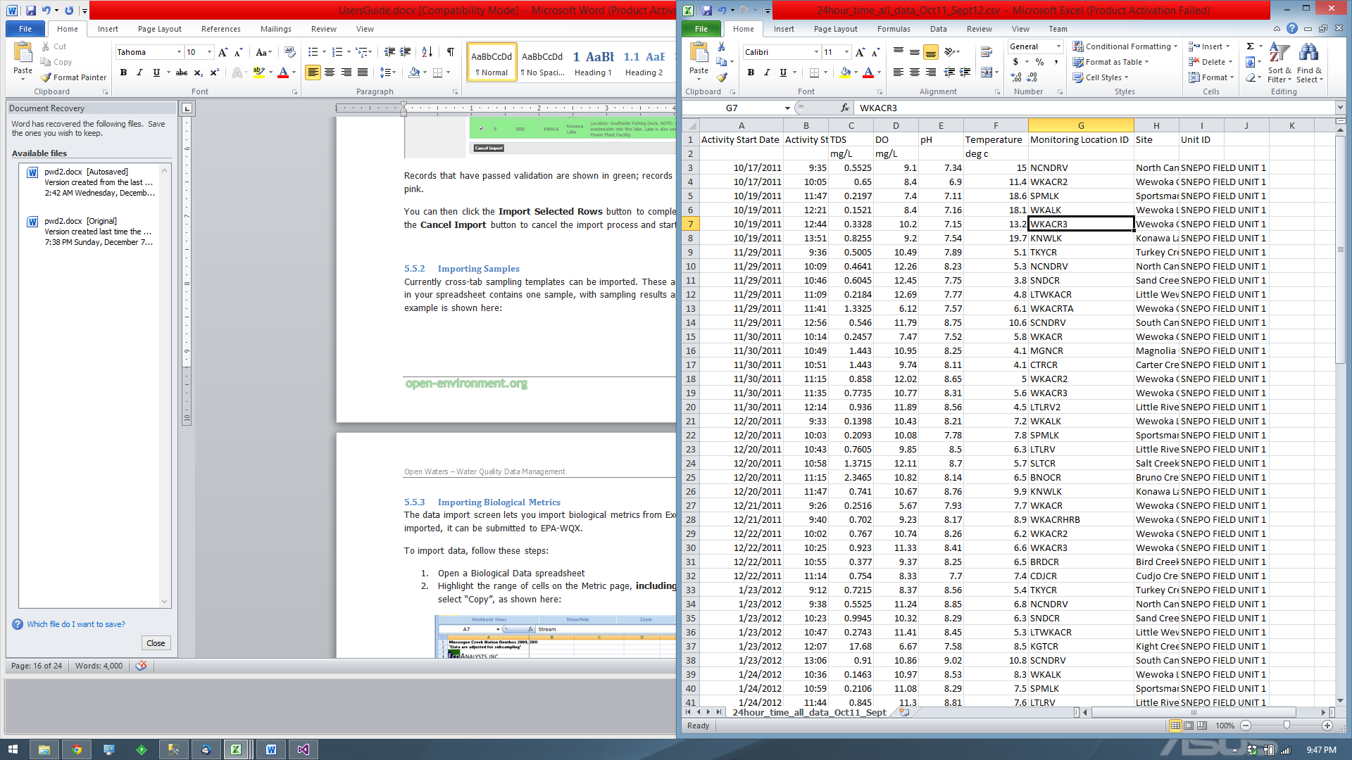

To import this data, you will first need to define import logic. This will tell the system what type of data is in each column. To define a new import logic, select the import data structure = “Sample Results – 1 Row Per Sample”, then click on the “Define New / Edit Import Logic”, as shown here:

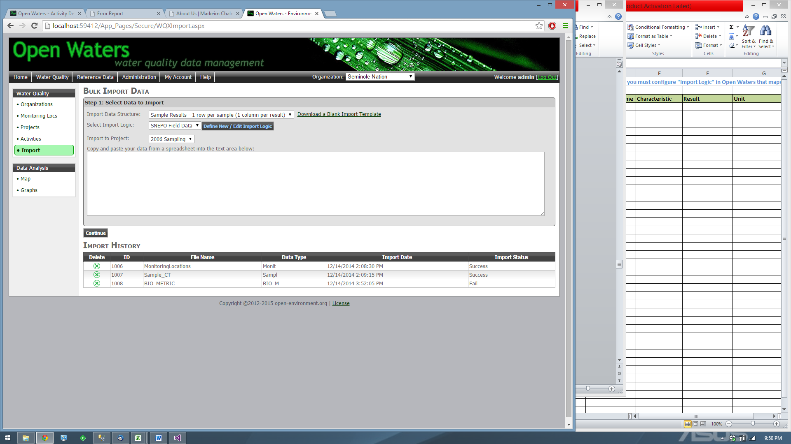

This will display the Import Logic Templates page. Click the “Define New Import Logic” button, select “Sample (1 row per sample)” and give your import logic a new name.

Then click the “Select” button. Two grid will appear:

* **Mapped Columns:** here you will define all of the columns you wish to import into Open Waters
* **Hard-Coded Values:** here you will define any default values you wish to set when importing data

**Mapped Columns:** When adding Mapped Columns, follow these guidelines:

* Column Number: enter the integer representing the column number of your import data
* Field: the following fields can be imported:
  + Activity Comments
  + Activity Media
  + Activity Start Date
  + Activity Submedia
  + Activity Type
  + Activity ID
  + Characteristic
  + Monitoring Location ID
  + Result Value Type
  + Result Status
* Characteristic Name: (only applicable when the mapped column is Characteristic) This must exactly match the name of a characteristic in Open Waters
* Characteristic Unit Code: (only applicable when the mapped column is Characteristic) you can specify a unit that will be populated each time the characteristic is imported. The unit code must exactly match a unit code in Open Waters

Hardcoded Data: When adding Hardcoded data, follow these guidelines:

* The following fields can be hard coded:
  + Activity Comments
  + Activity Media
  + Activity Start Date
  + Activity Submedia
  + Activity Type
  + Activity ID
  + Characteristic
  + Monitoring Location ID
  + Result Value Type

### Importing Biological Metrics

The data import screen lets you import biological metrics from Excel into the database. After data is imported, it can be submitted to EPA-WQX.

To import data, follow these steps:

1. Open a Biological Data spreadsheet
2. Highlight the range of cells on the Metric page, **including the column and row headers**, then select “Copy”, as shown here:

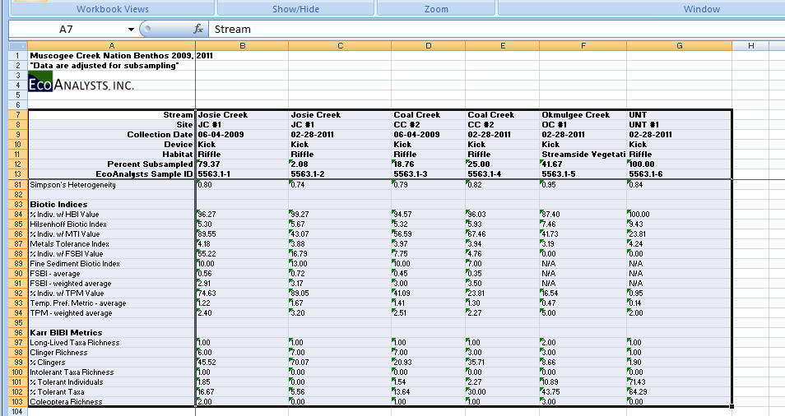

***Figure 5.10: Data Import – Copy Data from Excel***

1. In Open Waters, paste the data into the large Textbox, as shown here:

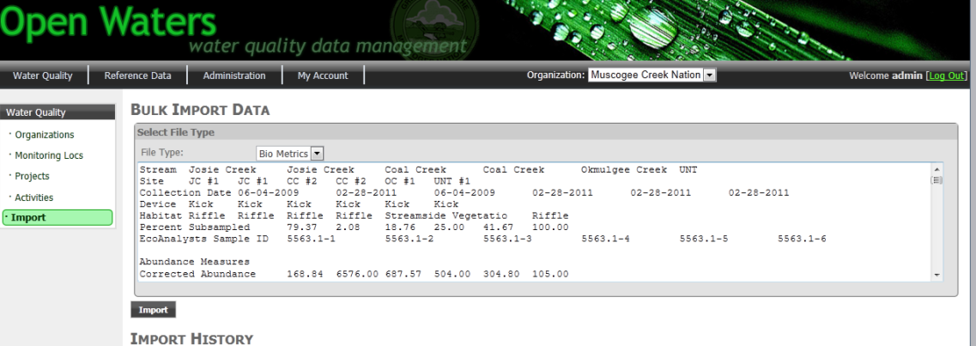

***Figure 5.11: Data Import – Paste Data into Open Waters Textbox***

1. Specify which Project you would like to import the data into.
2. Then click the Import button. This will import data to the Open Waters database.

## Data Analysis

### Maps

**Site Navigation:** Water Quality 🡪 Map

The Maps screen allows you to view monitoring locations and results geospatially.

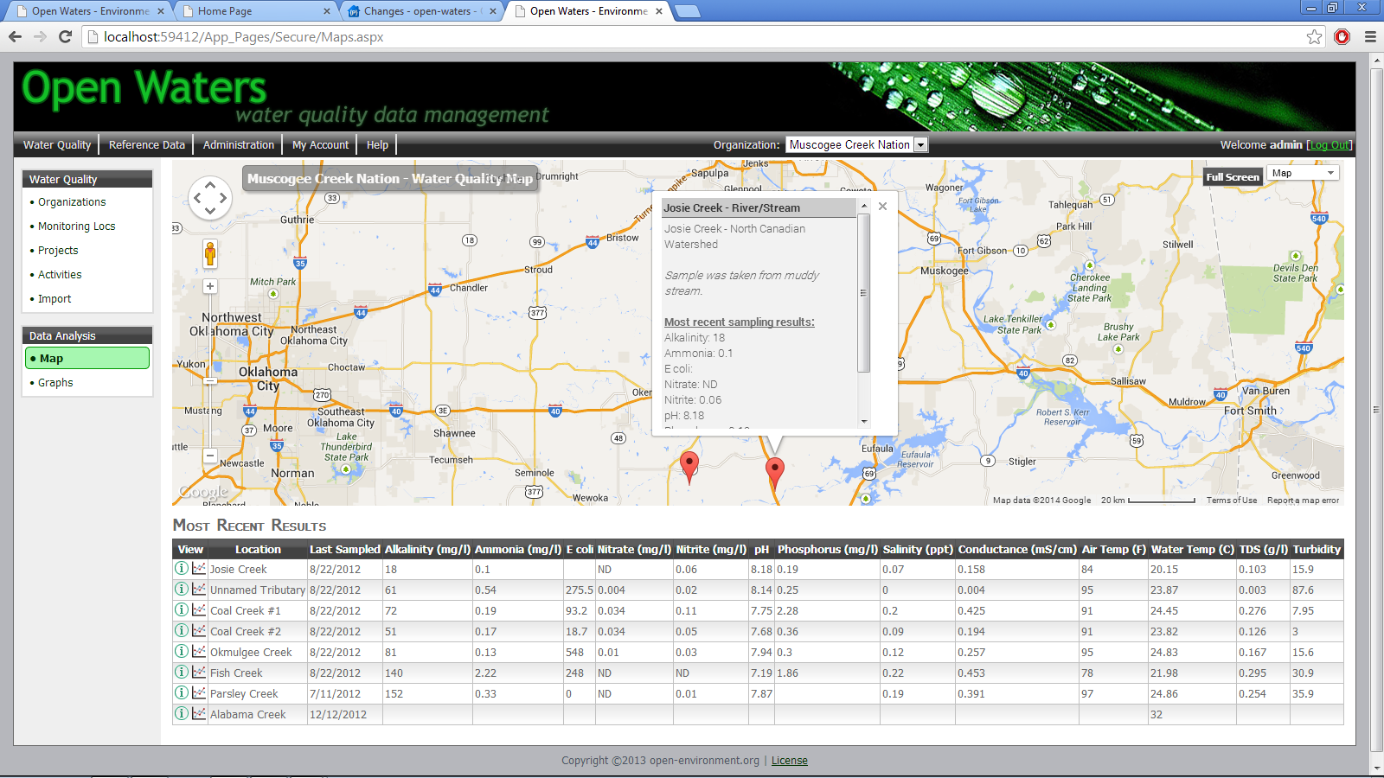

***Figure 5.12: Data Analysis - Map***

The map will display the monitoring locations for your organization. To view additional details for a particular monitoring location, you can click the icon on the map.

The datagrid below the map will display the most recent sample taken at each location. Two icons appear in the 1st column of the datagrid. This allows you to view all sample results taken at the particular location, or view graphs for the data at this location (see next section for graphing details).

### Graphs

**Site Navigation:** Water Quality 🡪 Graphs

The Graphs page allows you to view data for a particular monitoring location and characteristic in a time-series graph.

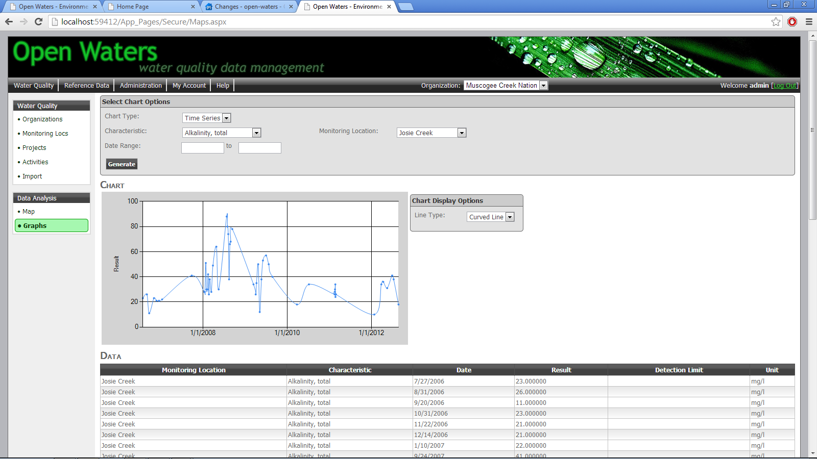

***Figure 5.13: Data Analysis - Graphs***

# Administering Open Waters

This section describes several tasks for administering the Open Waters application.

## General Application Settings

**Site Navigation:** Administration 🡪 App Settings

The General Application Settings page lets Administrators configure several important global application settings.

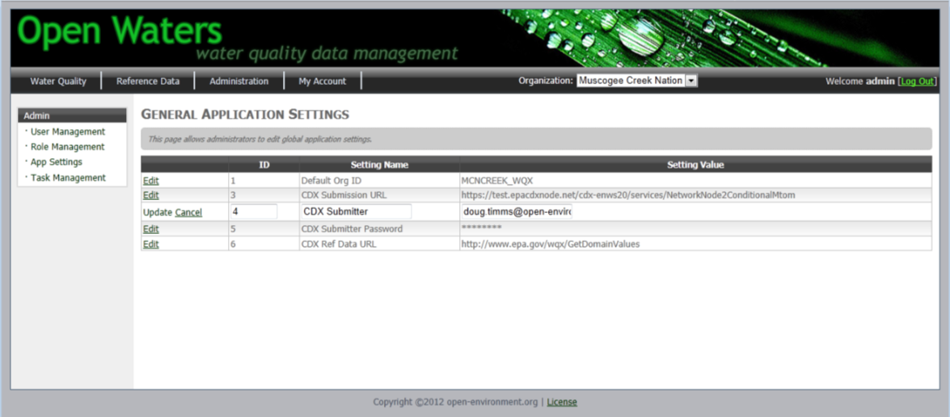

***Figure 6.1: General Application Settings Page***

To edit a record, click the Edit link in the first column, change the value, then click the Update link. These changes are stored in the database. The following table lists the various application settings and their meanings:

|  |  |
| --- | --- |
| **Setting** | **Description** |
| CDX Submission URL | The URL to which WQX XML submissions will be made. |
| CDX Ref Data URL | The URL from which Open Waters will retrieve WQX reference data. |
| CDX Submitter | The default NAAS account used when submitting data to EPA. However, if you specify a CDX Submitter at the Organization level it will take precedence over this value. |
| CDX Submitter Password | The default NAAS account password used when submitting data to EPA. |
| Log Level | When set to “DEBUG”, Open Waters will save a copy of the XML file used when submitting data to EPA. |
| EMAIL FROM | Open Waters sends out emails to people when they register a new account. Emails will originate from this email address. |
| EMAIL SERVER | The email server (IP address) used by Open Waters to send emails out. |
| Default State | When pulling reference counties from EPA’s WQX reference data, only counties for this state will be pulled. |

## Managing Users & Roles

**Site Navigation:** Administration 🡪 User Management

Administrators can manage users and user access rights in the application. At the User Management screen Administrators can view a listing of current users.

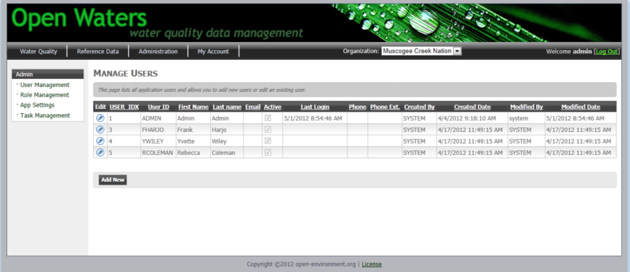

***Figure 6.2: User Management***

* **Change a User’s Password:** To edit a user, click the pencil icon.
* **Add a new User:** Click the Add New button at the bottom of the screen.
* **Delete a User:** First click the Pencil icon to edit the user, then deselect the “Active” checkbox to Inactivate the user. (To completely delete a user’s record, you must remove it directly in SQL Server)

**Role Management:** Roles define which screens in the application a user can access. Open Waters includes two roles as defined here:

|  |  |
| --- | --- |
| **Role** | **Access Rights** |
| ADMIN | Unrestricted |
| USERS | All screens except:   * Admin🡪User Management * Admin🡪Role Management * Admin🡪App Settings * Admin🡪WQX Management * Water Quality 🡪 Organizations 🡪 Add New Org button |
| READONLY | Cannot add, edit, or delete activities |

To add or remove a user from a role, click on the **Role Management** screen:

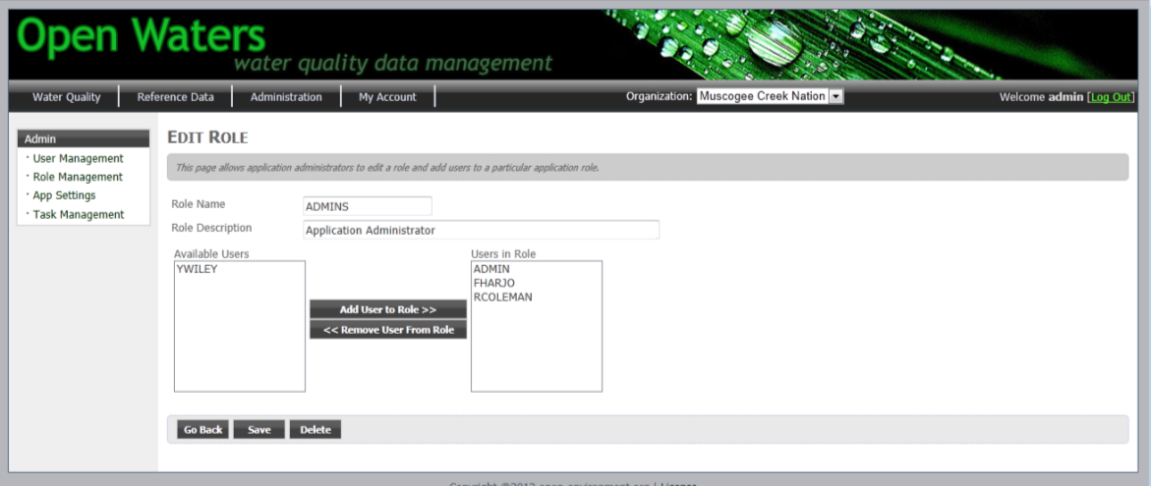

***Figure 6.3: Role Management***

Click the Add User to Role or Remove User From Role buttons.

## Synchronizing Reference Data from EPA

**Site Navigation:** Reference Data

The Reference Data screen allows you to view the reference data in Open Waters and also retrieve the latest reference data from EPA.

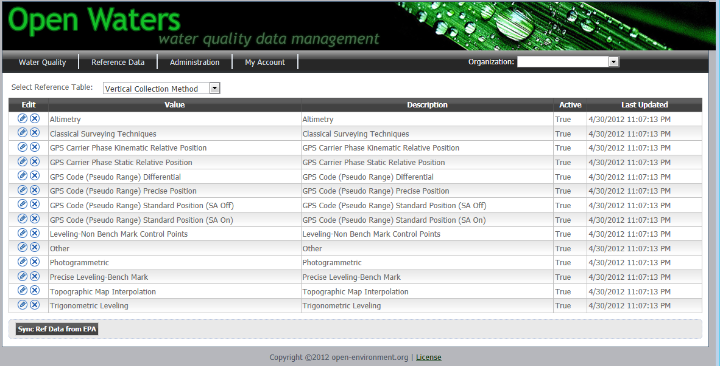

***Figure 6.4: Reference Data Management***

When you click the **Sync Ref Data from EPA** button, Open Waters will import the following sets of reference data from EPA:

* **Organization Level:**
  + Tribes
* **Project Level:** 
  + Sampling Design Type Code
* **Monitoring Location Level:**
  + County
  + Country
  + Horizontal Collection Method
  + Horizontal Reference Datum
  + Monitoring Location Type
  + State
  + Vertical Collection Method
  + Vertical Reference Datum
  + Well Formation Type
  + Well Type
* **Activity (Sample) Level:**
  + Activity Media
  + Activity Media Subdivision
  + Activity Type
  + Relative Depth
  + Net Type
  + Sample Collection Equipment
  + Sample Container Color
  + Sample Container Type
  + Sample Tissue Anatomy
* **Results Level**
  + Analytical Method
  + Characteristic
  + Measure Unit
  + Result Detection Condition
  + Result Laboratory Comment
  + Result Measure Qualifier
  + Result Sample Fraction
  + Result Status
  + Result Temperature Basis
  + Result Time Basis
  + Result Value Type
  + Result Weight Basis
  + Taxonomy
* **Multiple Uses**
  + Time Zones

**After clicking the Import button, do not refresh or leave the page until the import process has completed. Because over 30,000 reference data records are imported from EPA, this import process may take up to 15 minutes.**

**Configure Data Import URL:** Data will be retrieved from the EPA website which can be configured by changing the “CDX Ref Data URL” setting found on the Admin 🡪 App Settings page.

**Data Import Logic:** All data will be matched based on value – if new values are added from EPA they will be added in Open Waters. If a description for an existing value is updated, it will be updated in Open Waters. If a value is removed from EPA, it will not be removed from Open Waters.